**IOT PHASE 5**

Topic:Air Quality Monitoring

Team Members:Bharath U, Jerome Joshua M, Noshok S, Prasanth M

Mentor: Sundarraj V

OBJECTIVE:

The objective of our Air Quality Monitoring IoT project is to develop a highly efficient and reliable system for real-time air quality measurement and analysis.

This initiative aims to address the pressing global issue of deteriorating air quality, which has significant health and environmental implications. Through the deployment of a network of IoT sensors, we intend to continuously monitor various air pollutants, such as particulate matter, volatile organic compounds, carbon monoxide, and nitrogen dioxide.

Our primary goals are to provide accurate and accessible air quality data to the public, support timely decision-making for pollution control, and raise awareness about the importance of clean air. By leveraging IoT technology, cloud-based data analytics, and user-friendly interfaces, we aim to empower individuals, communities, and policymakers to take proactive measures to improve air quality, ultimately contributing to better public health and a more sustainable environment.

DEVICE SETUP:

BOARD:Arduino UNO board

SENSORS:

1. Particulate Matter (PM) Sensor: PM sensors measure the concentration of fine and ultrafine particles in the air. These particles can be categorized into PM1, PM2.5, and PM10, based on their size. PM sensors are crucial for assessing the presence of harmful airborne particles, which can have adverse effects on respiratory health.

2. Gas Sensors: Gas sensors are designed to detect specific gases such as carbon monoxide (CO), nitrogen dioxide (NO2), sulfur dioxide (SO2), and ozone (O3). They provide valuable data on the levels of these gases in the atmosphere, which are known to be air pollutants and can have health and environmental impacts.

3. Volatile Organic Compounds (VOC) Sensor: VOC sensors detect a wide range of organic compounds present in the air, which can originate from sources like industrial emissions and vehicle exhaust. Monitoring VOCs is essential for understanding indoor and outdoor air quality and can be important for health and safety reasons.

4. Temperature and Humidity Sensor: While not specific to air pollutants, temperature and humidity sensors are often integrated into air quality monitoring systems. These sensors provide context and enable the correction of certain pollutant measurements, as environmental conditions can affect pollutant behavior in the air.

5. Carbon Dioxide (CO2) Sensor: CO2 sensors measure the concentration of carbon dioxide in the air. While CO2 itself is not a pollutant in the same way as some other gases, its levels can indicate indoor air quality and ventilation adequacy, making it important for both health and energy efficiency considerations.

These sensors, when integrated into a comprehensive air quality monitoring system, provide a holistic view of air quality, helping to identify and address pollution issues in various environments, from industrial areas to urban and residential settings.

PYTHON CODE:

#include <Arduino.h>

#include <WiFi.h>

#include <BlynkSimpleEsp32.h>

#include <Adafruit_SSD1306.h> // Use the appropriate library for your digital screen

char auth[] = "9bc1579557394381a23c31";

char ssid[] = "WIFI_SSID";

char pass[] = "12345678";

#define SMOKE_SENSOR_PIN 2 // Replace with the actual pin you've connected the smoke sensor to

#define SCREEN_WIDTH 128

#define SCREEN_HEIGHT 64

Adafruit_SSD1306 display(SCREEN_WIDTH, SCREEN_HEIGHT, &Wire, -1);

void setup() {

Serial.begin(115200);

Blynk.begin(auth, ssid, pass);

display.begin(SSD1306_SWITCHCAPVCC, 0x3C); // Check the I2C address of your display

display.display();

delay(1000);

display.clearDisplay();

}

void loop() {

float smokeValue = digitalRead(SMOKE_SENSOR_PIN); // Read smoke sensor data

// You may need to map the sensor values to meaningful air quality levels

Blynk.run();

display.clearDisplay();

display.setTextSize(1);

display.setTextColor(SSD1306_WHITE);

display.setCursor(0, 0);

display.println("Air Quality:");

display.setTextSize(2);

display.setCursor(0, 20);

display.println(smokeValue);

display.display();

delay(1000); // Adjust the delay as needed

}

OUTPUT:

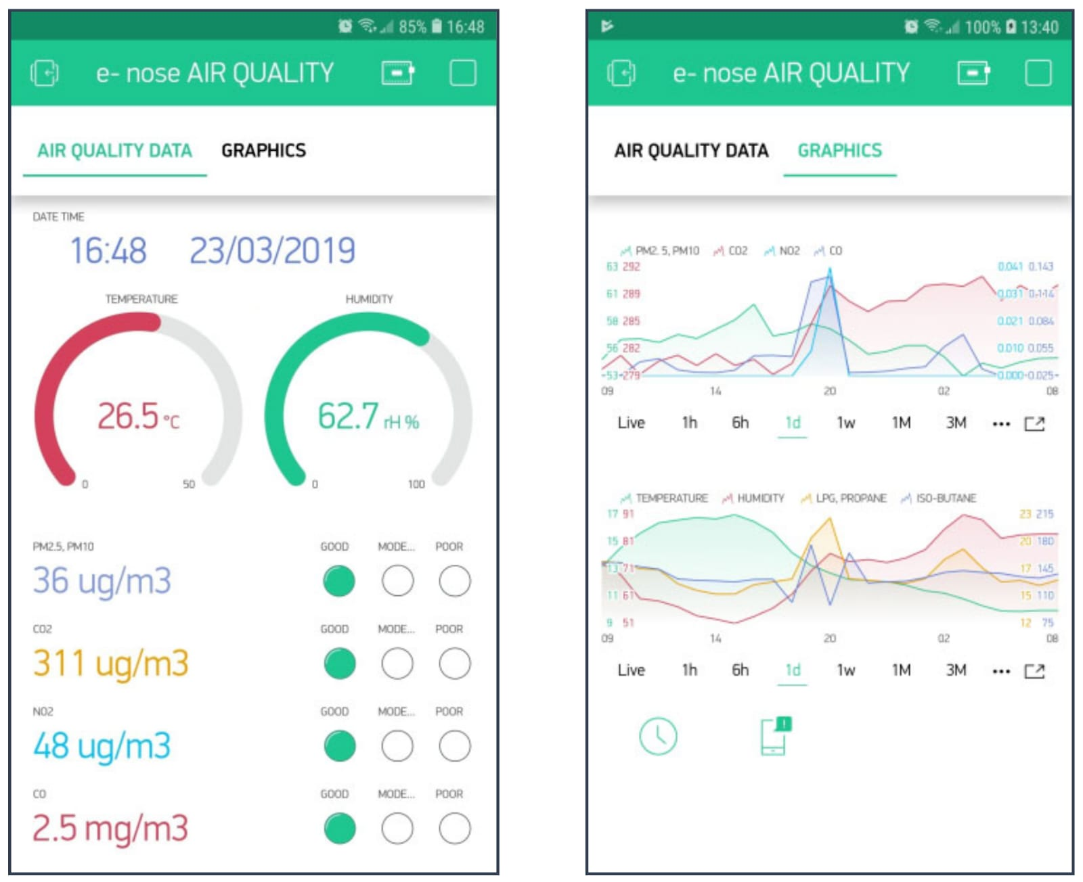

**TICKER CAD DESIGN**

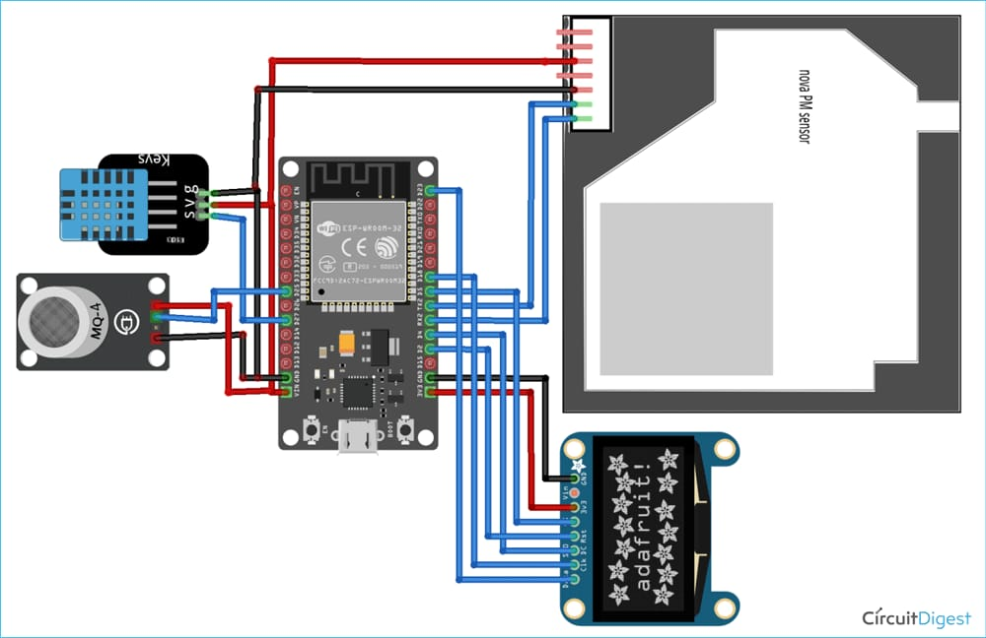

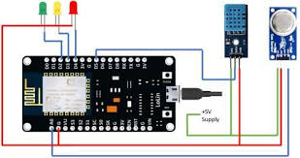

**HARDWARE SETUP FOR AIR QUALITY MONITORING**

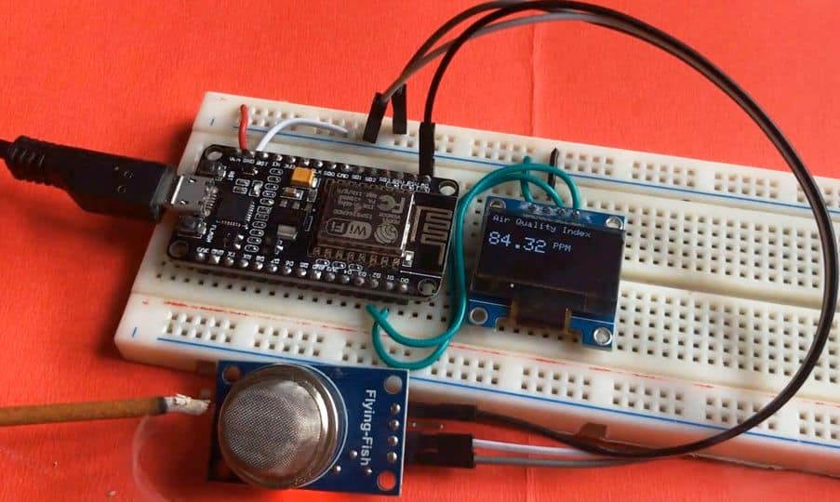

**REAL TIME APPLICATION DATA**

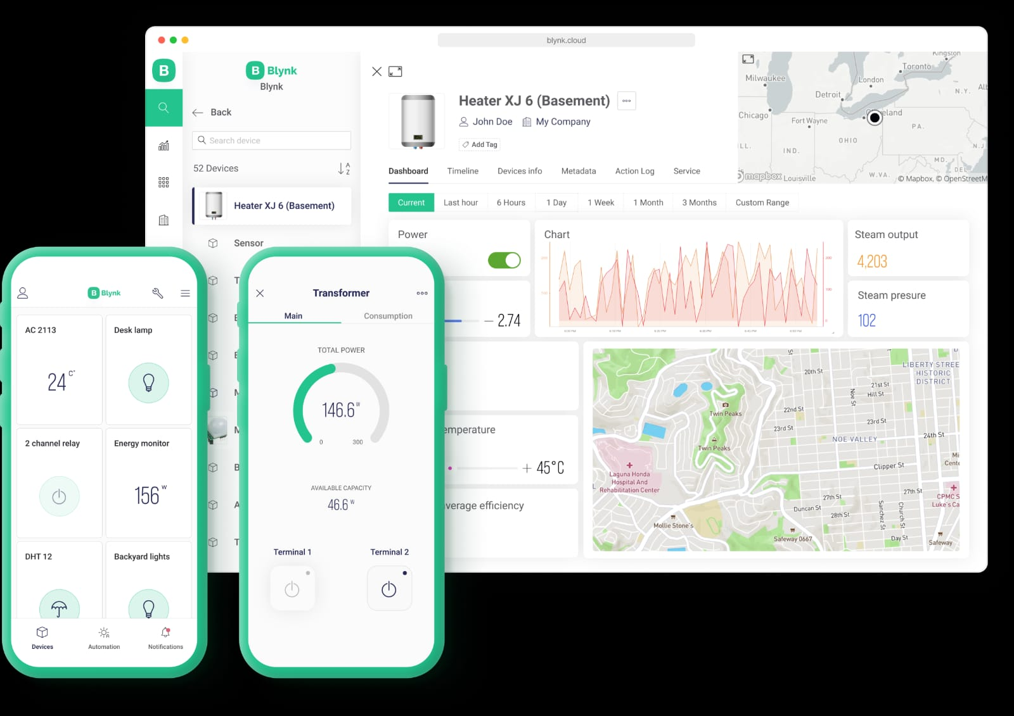

PUBLIC AWARENESS:

Real-time air quality monitoring using IoT (Internet of Things) technology can have significant health impacts on people by providing valuable information and insights into the quality of the air they breathe. Here are five key health impacts of real-time air quality monitoring:

1. Awareness and Education: Real-time air quality data can raise awareness about the quality of the air in a specific area, helping individuals and communities better understand the potential health risks associated with air pollution. This knowledge can encourage people to take proactive steps to protect their health.

2. Respiratory Health Management: Individuals with respiratory conditions such as asthma or chronic obstructive pulmonary disease (COPD) can use real-time air quality information to make informed decisions, like staying indoors on days with poor air quality, adjusting medication, or using protective measures, which can help manage their conditions more effectively.

3. Allergy Management: People with allergies to pollen or other allergens can benefit from real-time air quality monitoring to track allergen levels. This information can assist them in taking preventive measures and choosing the right times for outdoor activities to reduce exposure to allergens.

4. Vulnerable Populations: Real-time air quality monitoring is particularly important for vulnerable populations such as children, the elderly, and individuals with pre-existing health conditions. It allows caregivers and healthcare providers to make informed recommendations for these groups, such as avoiding outdoor activities during times of high pollution.

5. Public Health Policies and Interventions: Real-time air quality data can inform public health policies and interventions, leading to the development of strategies to reduce air pollution and its health impacts. This can include emission controls, urban planning, and public awareness campaigns that aim to improve air quality and overall health.